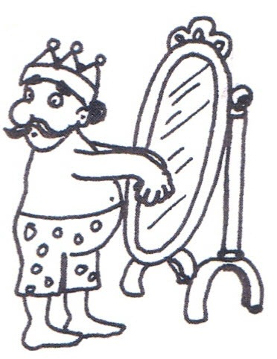

Developing and Managing a PBL curriculum at YLS is challenging because:

CONTENT

- Substantive content is often presented in an illogical order
- Workable problems are difficult to draft
- The content can become static: If it ain’t broke, don’t fix it
- There is no hierarchy of learning outcomes, so minor issues can have undue prominence
- Law has a very prescriptive regulatory framework

ADMINISTRATIVE

- It involves considerable inter-module dialogue
- It is difficult to share modules with other departments where students are not familiar with PBL

ASSESSMENT

- There should be assessment of the process but this is very difficult to do fairly and consistently. We currently do not do this at YLS
- Reflection is very important but this is difficult to assess consistently. A reflective report currently accounts for 10% of the core modules and is also assessed in skills modules

ROLE OF STAFF

- The module leaders have limited opportunities to provide structure and guidance on assessment technique
- The PBL tutors are torn between their role as facilitators and their instincts as teachers (particularly with weak groups)

ROLE OF STUDENTS

- The model is based on co-operative group work – this doesn’t always happen
- The model is based on 100% attendance – this doesn’t always happen
- The process can get repetitive, which can lead to disengagement
- The students become great problem identifiers – but not always problem solvers

EPISTEMOLOGICAL ORIGINS

- Students question the nature of the problem (naturalism)
- Knowledge is personal and students use their own reasoning abilities (metaphysics)
- The emphasis is on deductive reasoning (rationalism)
- Students gain knowledge through gathering information (empiricism)
- Students get to connect knowledge learned in academe with knowledge needed in the wider world (phenomenologicalism)
- Students are encouraged to challenge and deconstruct the frameworks of the subject they are studying (positivism)
- Students develop self-directed learning skills (existentialism)
- It helps to produce political agents (postmodernism)

THEORIES OF LEARNING

- There is an improvement of learning through feedback (behavioural)
- It develops mental processes such as insight, memory and perception (cognitive)
- It addresses different approaches to learning, such as deep, surface and strategic (cognitive development)
- It involves the whole person, to include prior knowledge (humanist)
- Students have the opportunity to construct knowledge for themselves (constructivist)
- It is based on the view of education as a process of continuous reconstruction and growth of experience (experiential learning)

With acknowledgement of, and apologies to, Maggi Savin-Baden, and Claire Howell Major and their book Foundations of Problem Based Learning (2004)

A curriculum based on PBL is great because:

